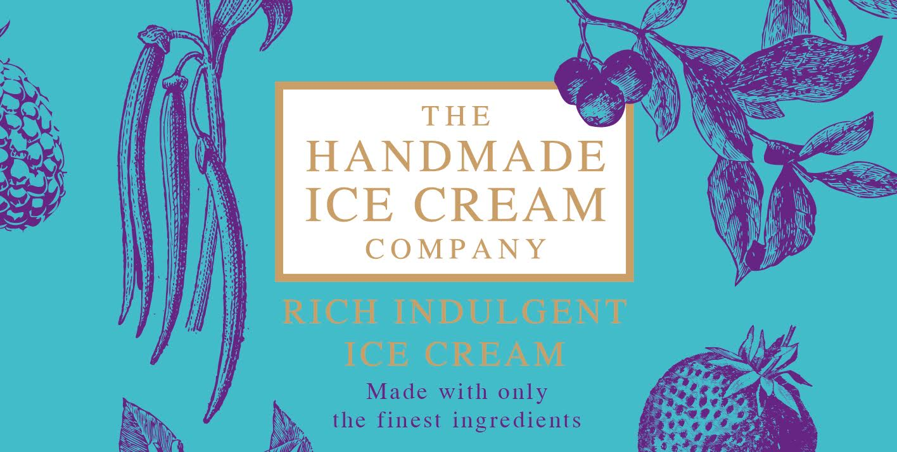

THE BEST PRODUCTS REQUIRE THE BEST INGREDIENTS

“The best products require the best ingredients” Pure whole milk and rich double cream, Chef made ice cream when only the best will do, ice cream without comprise using only the finest ingredients and no funny business, we only do Luxury.

The Handmade Ice Cream Company, Handmade artisan ice cream made in the heart of The Lake District.

Following 15 successful years as a professional pastry Chef in some of the country’s top hotels and restaurants there was a notable gap in the market for chefs who wanted to make their own ice cream but due to Equipment, time, staff etc this wasn’t always possible. This normally resulted in having to buy in a mass made commercial ice cream pumped full of added air, artificial flavour compounds, syrups, colourings and extracts.
So we wanted to be different and produce a completely natural ice cream without all the funny business put in and using only the finest natural ingredients. We also wanted complete control of what goes into our ice creams so we make in house our own gingerbreads, sticky toffee puddings, caramels, toffees, fruit compotes & fruit purees this means we don’t use any artificial flavours or preservatives only the finest all natural ingredients.
We hand select the finest Madagascan Vanilla pods and richest Belgium Chocolates bought directly from the producers, this is both costly and time consuming but like all artisan producers we set out with the idea to produce a product with passion, craftsmanship, pride and love as we believe these elements achieve the true sense of an artisan product and sets us apart from the commercial mass producers.
We are very proud of our products and we hope you love them.

2023 FLAVOURS
“The best products require the best ingredients” Pure whole milk and rich double cream, Chef made ice cream when only the best will do, ice cream without comprise using only the finest ingredients and no funny business, we only do Luxury.
Ice Creams | Gluten Free = GF Vegetarian = V Vegan = VE | Sizes available
Madagascan Vanilla Pure Madagascan Vanilla Pods hand selected, when only the best Vanilla will do | GF,V | 5 litre | 500ml | 125ml
Caramel, Honeycomb & Fudge Rich buttery caramel ice cream mixed with clotted cream fudge and honeycomb | GF, V | 5 litre | 500ml | 125ml
Double Belgian Chocolate The best 70% Belgian Chocolate melted into rich creamy ice cream with small Chocolate chunks | GF, V | 5 litre | 500ml | 125ml
Crushed Strawberries Crushed Summer sweet strawberries mixed into Luxury Dairy ice cream | GF, V | 5 litre | 500ml | 125ml
Raspberry Meringue Eton Mess Fresh raspberry mixed with a hint of vanilla and meringue pieces | GF, V | 5 litre | 500ml | 125ml
Homemade Gingerbread Home made in house Gingerbread mixed into a Stem ginger & treacle base Luxury dairy ice cream | V | 5 litre | 500ml | 125ml
Sticky toffee pudding sauce swirl The famous sticky toffee pudding sauce rippled into our luxury ice cream | GF,V | 5 litre | 500ml | 125ml
Biscoff biscuits Made with the famous caramelised Lotus Biscoff biscuits | V | 5 litre | 500ml | 125ml
Salted buttery Caramel When it comes to salted Caramel we only use the best Cornish Sea salt and rich buttery caramel | GF, V | 5 litre | 500ml | 125ml
Mint chocolate chip Pure green peppermint luxury ice cream with Belgian chocolate pieces | GF | 5 litre | 500ml | 125ml
Mango & passion fruit A winning combination of summer ripe mangos with a sweet passionfruit ripple | GF, V | 5 litre | 500ml
Irish Cream Liquor Plenty of rich silky smooth Baileys for a rich indulgent ice cream | GF, V | 5 litre | 500ml
Ferrero Rocher Indulgent doesn’t get better than this made with smashed Ferrero Rocher | GF, V | 5 litre | 500ml
Lemon Meringue Pie Handmade lemon curd with Meringue and biscuit pieces bound in rich luxury dairy ice cream | GF, V | 5 litre | 500ml
Kinder Bueno Made with the best white chocolate, Nutella and hazelnut bars | V | 5 litre | 500ml
Cornish Clotted Cream Made with Only the best Rodda Cornish clotted cream, complete luxury in every scoop | GF,V | 5 litre
Malty teaser Luxury dairy ice cream loaded with smashed Maltesers | V | 5 litre
Banoffee pie Banana and toffee with crunchy biscuit | V | 5 litre
Rocky road Milk chocolate ice cream with marshmallows, raisins and biscuit pieces | GF | 5 litre
Candy floss Traditional candy floss flavour and strawberry millions not just for children | GF, V | 5 litre
Cinder toffee crunch Gorgeous chunks of cinder toffee mixed into toffee ice cream | GF, V | 5 litre
Rhubarb & Custard Homemade rhubarb compote laced onto a rich Custard ice cream | GF, V | 5 litre
Jaffa cake Our luxury dairy ice cream swirled with orange and chocolate sauce | GF, V | 5 litre
Bubble-gum All natural flavours and colours make this a favourite | GF, V | 5 litre
Blackcurrant & Clotted cream Homemade blackcurrant compote swirled into our luxury clotted cream ice cream | GF, V | 5 litre
Raspberry ripple A seaside classic for good reason luxury ice cream rippled with sweet raspberry sauce | GF, V | 5 litre
Cherry ripple Rich luxury ice cream with sweet cherry swirl | GF, V | 5 litre
Cinder toffee and Chocolate sauce Luxury ice cream rippled with rich chocolate sauce and cinder toffee pieces | GF, V | 5 litre
Pistachio Pure Roasted Pistachios bound with Luxury dairy ice cream, a classic for good reason | GF, V | 5 litre
Oreo Cookies & cream Rich creamy dairy ice cream with Oreo cookie chunks | V | 5 litre
Christmas Pudding Made with only the best Christmas pudding recipe laced with warming liquors | V | 5 litre
Sorbets Made with pure fruit juices and purees for a completely natural refreshing taste | Gluten Free = GF Vegetarian = V Vegan = VE | Sizes available
Blood Orange  Strawberry  White Peach and Basil  Lemon  Raspberry  Passion Fruit  Dark Chocolate  White Chocolate  Mango | GF, VE,V | 2.5 litre
Lemon | GF, VE,V | 2.5 litre
Raspberry | GF, VE,V | 2.5 litre
Passion Fruit | GF, VE,V | 2.5 litre
Mango | GF, VE,V | 2.5 litre
Blackcurrant | GF, VE,V | 2.5 litre
Spiced Mulled Wine (Christmas) | GF, VE,V | 2.5 litre
VEGAN Our incredible plant based ice creams are smooth, indulgent and full of flavour
Vegan Coconut A creamy dairy free ice cream that has become a company favourite | GF,VE | 2.5 litre
VEGAN Oreo cookies & cream Rich creamy dairy free ice cream with Oreo cookie chunks | VE | 2.5 litre
Vegan biscoff biscuits Made with the famous caramelised Lotus Biscoff biscuits | VE | 2.5 litre
Vegan Madagascan Vanilla Pure Madagascan Vanilla Pods hand selected, when only the best Vanilla will do | GF,VE | 2.5 litre | 125ml
Vegan Strawberry Crushed Summer sweet strawberries | GF,VE | 2.5 litre
Vegan Belgian Chocolate Rich and Chocolatey using the finest Belgian Chocolate | GF,VE | 2.5 litre

